User-CenteredDesign Assignment 1 User-Centered Survey

Prepared for: UCD [COSC2653](https://rmit.instructure.com/courses/56619), Study Period 4 2019

Prepared by: Benjamin Tomlinson, s3390149

4th January 2019

(Kumar, 2020)

Part 1. Analysis of Application

Introduction

The Facebook application is a cloud client to access Facebook without going through a browser, but it still requires an active internet connection to use it. Facebook can also be run on multiple browsers, for instance, google chrome, internet explorer and Firefox, but due to the scope this will not be covered. Facebook can also be run across any mobile device or desktop using the Facebook application and through a browser in multiple operating systems. However, what this analysis will cover is the use of the Facebook application through Android and not through a browser but in a mobile technological context with the app because of the volume of mobile users is greater than desktop usage.

As in the specifications for the report, only users of the Facebook application on the Android platform were eligible to undertake the survey as it was the scope of the analysis. The analysis covers how the Facebook applications design affects a current user and their ability to perform the following tasks associated with the social media platform. In the analysis is; ease of regular logging in or off; customising a personal profile, group or business page; posting content as a user or an administrator.

Part 1.1 Intended users

Attributes of a portion of users are distinct but it is a requirement to meet the specifications of the application analysis that the users are assumed to have the ability to carry out basic tasks in Facebook. It is also assumed that the users who take the survey are active participants in the platform and at least use it occasionally as the analysis does not cover potential users.

Demographics of individuals are omitted in this analysis and evaluation as it focuses on the design of the application and a general individual user scope interaction.

|  |  |  |  |
| --- | --- | --- | --- |
|  | Business and Marketing | Personal Users | Groups and Communities |
| **A**  **T**  **T**  **R**  **I**  **B**  **U**  **T**  **E**  **S** | * Marketing firms * Small, medium and large businesses * Entrepreneurs * B2B (Business to Business) focused * B2C (Business to Customer) focused * Data analysis and data science for user statistics * New or existing businesses * Not geographical dependant for social media with access to the internet * Type of business and its structure determines how it will operate within the social media * 80 million pages of small and medium businesses | * Users vary in age from 13 to 65+ * Common age demographic of 25 – 39 * Globally, Facebook users consist of 43 per cent female and 57 per cent male * 2.4 billion monthly users * 1.4 billion daily users * 1 billion users are involved in groups * User characteristics, factors and behaviours vary according to region and geographical location * 96per cent of users globally access Facebook through mobile devices * 75per cent on average spend 20 minutes using Facebook | * Public, closed or secret groups * Admission dependant on privacy * A group has a central goal/s and purpose * Individuals have a role within the group * Formal and informal groups * Members typically share similar interests and characteristics * Characteristics consist of social, economic and cultural factors * Collaborating within the group to fulfill goals * Users in groups age 13 onwards * Geolocation independent for Facebook |
| **T**  **A**  **S**  **K**  **s** | * Analysing data from user interaction through provided tools * Applying strategies from results of compiled data * Serving existing clients * Expanding through finding new clients * Developing and maintaining reciprocal relationships with consumers and businesses through existing tools on the platform * Creating brand image through media content and communication with clientele * Maintaining company reputation through content and interaction * Posting company activities and marketing * Clarifying and resolving issues through posted content and direct communication * Informing clients of new changes to products and the company * Listening to consumers through UGC (user-generated content) on the business page. * Analysing consumer and business requirements through user requirements * Encourage consumers to create user generated content about the company for greater exposure (Even if it’s negative!) through posted content. * Sales of goods and services * Creating a page and company profile * Managing privacy and security policies * Logging on/off, regular use of the platform * Responding to user queries * Modifying the layout and content of the page | * Create content (User generated content) * Posting videos, photos, text * Interact and communicate to other users, businesses and groups * Share content and information * Maintaining relationships and creating new ones through communication tools * Finding and posting reviews of brands, companies and products * Finding and posting links to interesting content outside of Facebook * Play browser games * Finding information on events * Reading news feed for current events * Maintaining or actively participating in a group or community * Collaborating and coordinating with groups, communities or other users * Monitoring profile activities including one’s own * Monitoring business activities and may contribute to content or create it * Possible sales of goods and services through personal profile, group or company profile * Employment * Creating a personal profile * Managing privacy and security policies * Logging on/off, regular use of the platform * Modifying the appearance of the profile | * Posting information for events (new or existing) * Responding to user queries * Maintaining privacy and security * Collaborating and coordinating with users * Interaction with individual users, other groups or businesses through communicative tools * Keeping users informed of information relevant to the group through posted content * Posting media content such as videos and images * Sales of goods and services depending on the type of group and its objectives * Advertising * Creating and maintaining the group * Adding new members |

Part 1.2 Intended user tasks

Due to the length of this analysis the tasks listed in the analysis are restricted to account interaction, customising and overall communication with other users on Facebook through content creation.

Logging On

Logging on, this is a regular task in order to use and gain access to their account to be able to accomplish a task the user has set to do and cannot do without this process. Some users in odd instances may forget their password and need it to be reset in order to gain access to their account in which the password will need to be reset, which is another important and vital task for a user.

For users to be able to access their Facebook accounts, there are three options relating to identifying the user, which are: email address, phone number and username. if the user saves the account on the device, the user is not required to re-enter these details to login. This is helpful as the user can automatically login without having to re-enter their details and carry out their activities. However, for users that are security conscious it does present a potential issue because the details are saved including the password while automatically keeping the user logged in on the device that was used. The other issue, in order to login with a username it must be created first and this is a separate process to be carried out by the user as it is not automatically generated like the user ID. The user ID, however, is not displayed and the user must search for this to obtain their ID to use it. In order to turn off the automatic login and the option for the profile picture login including the saved password, is through the account security section which may be difficult to find through the various settings.

Password Reset

Password redundancy for a user is in the form of a link after selecting the profile photo to login in order to reset the password and a link to be sent to an email account or mobile through SMS. The user must then follow the instructions to reset their password, and for the password to be reset an email account or phone number to send a reset code to must be used. From this the user must enter the code or click a link from their email account and set a new password. Furthermore, after the action is complete the user is returned to their account without having to go through another login process and an email is sent of the occurrence of the password change. If a user is unable to reset their password or get their user ID and create a username, there is documentation and a link for further help.

Accessing a Group or Business Page

To access owned or manage a business page, the user needs to log in on their personal accounts and then search to get to their business page. The other method to gain access to a business page is to go to the hamburger icon on the nav bar and select pages in the navigation menu to locate the correct page. Without experience with a business page on Facebook a user may need to refer to the help section to find out how to gain access.

Similarly, with group pages it is the same process to gain access but with a unique icon when going through the navigation menu link.

Logging Off

Logging off, is another essential process in the user’s tasks as once a user has finished, they may want to log out of their account for multiple reasons including account security.

To log off Facebook the process is comparable across all devices and the menu to access this function along with other settings is in the menu of the navigation bar to the far right. Once this is selected the user must scroll down the menu items to reach the log off option in the menu, though it may be a simple process it is arduous as speed depends on the connection and how the user must scroll all the way to the bottom and may repeat the process numerous times any given day. The only benefit of this menu is that it is accessible in all the pages of a personal profile enabling uniform access to log off the profile.

The other method for forcing Facebook to log out is to go through to the security and privacy settings and to select the active sessions and end the session. Although this is another method, without looking at documentation and having previous experience as this is a more advanced setting, users may not be aware of the extra settings.

Customisation

Customising a profile is critical in Facebook and social media in general as individuals manipulate and modify their profile to suit them and reflect on who they are and show other users based on their profile. This is applicable to businesses and groups as they are customisable which enables groups and businesses to form an image or reputation based on their profile.

Customising a Profile

On the mobile application for Facebook to enable customisation of the profile the user must select the profile on the navigation bar and from there the user must select “Edit Profile” action button to edit “About Me” in a sub-menu containing personal details. Another option for customisation in the mobile application is through the hamburger menu with other settings that can be accessed, and it is the last option on the list. The settings are readily accessed although the icons in the navbar may be difficult to interpret for an inexperienced user. There are countless settings for news feeds, privacy and security along with many more that can be altered, this may seem overwhelming to a user because of the information to traverse to complete their preferred profile setup.

Customising a Business Page

Customising a business page, tasks to customise the page include, adding a cover photo, adding public business details and editing various settings to manage the page

On a business page to customise the details, the admin of the page needs to locate various places on the page to change a setting including a horizontal scroll menu for the main information for the page. A user adding a profile picture of the business the admin must select the placeholders and it will display an update message, likewise the cover image has a notification to select an image. However, there are numerous settings to set up a business page and it may take some time to complete the process. Although the layout for a business page is vastly different to a profile page and it is less cluttered with a clearly labelled interface, however like a profile there are countless settings that are in menus and sub-menus which can be confusing to locate. Also, with comparing to a group page more advanced settings are available, however on the android Facebook app it does not appear to have the same level of control on a mobile device using android.

Customising a Group Page

Customisation for a Facebook group includes the name, description and the photo of the group, moderating the group and settings, adding sections to the page and connecting with existing pages. The layout is less cluttered, and settings are easily located on the group page itself by selecting an icon in the top right-hand corner of the screen.

Posting Content

Posting content on social media is the main purpose of social media, hence the name, as it’s in a social context where anyone can see what has been posted by a user. This is a regular task and form of communication in the Facebook application itself as instant messaging has been delegated to the messenger application which is not covered in this scope. Types of content range from comments to reply or contribute conversely to contextual discourse, visual media including images and videos to live feeds.

Posting Content on a Personal Profile Using a Mobile Device

Content posted on the Facebook app can be done through the news feed on the home page where user, business and news associated feeds are displayed. The other alternative to this is to go to the page directly, consistently the option to choose the media is displayed in a pop-up menu when the user selects to post content. The process is simple to locate where the options are to post content on a personal profile.

Posting Content on a Group Page Using a Mobile Device

The interface of the group page shares similarities with a business page in that posting content can either be done on the page itself by selecting the option on the page feed or going through another horizontal scroll menu to locate the required function. As a user, corresponding options for posting content are the same regardless, this enables a user to recall where options can be selected to post content as it is consistent for the user and admin.

Posting Content on a Business Page Using a Mobile Device

Posting content on a business page using a mobile device is fairly simple and the user has clearly labelled icons to display where to find the option, once selected the user must then choose what type of post they want to create with the chosen media. In the middle for the page for the admin contains the menus in the horizontal scroll bar to post content on the page. A user, however, can send a message directly to the page owner and the user has the same menu to be able to access content posted by the page admin and create posts themselves. Although a user and admin do not have the same permissions and features, regardless, the layout for a user and business is clearly defined and easy to navigate in order to post content on the page. The exception to this is the extra functionality and features the admin has that the user doesn’t.

Part 1.3 Application Heuristic Analysis

For this analysis of the Android Facebook application, the Nielsen Norman groups heuristics were selected as the basis to evaluate the application against a set of heuristics. There is a total of 10 main heuristics which are a set of standards to designing and building a user interface in order to fulfil a user’s needs and goals.

**1# Visibility of system status (Nielsen Norman Group, 2019).**

The first heuristic in the Nielsen Norman group is that the system should provide feedback within a specified timeframe (Nielsen Norman Group, 2019). When a user goes through each menu, the response is immediate, and a sub-menu is displayed if one exists. There is some feedback when going between pages and there is a slight delay in-between the user being redirected. Once this occurs, items that still have not loaded are shown with an indicator that repeats until the section of the page has fully loaded. When logging on and off there is an indicator until the user has gained access or successfully logged off the system.

This is applicable to all user groups as feedback is vital in providing the user further direction of their next action if the current one was successful and indicate otherwise if it failed when the user tried to interact. As with this heuristic and not to overwhelm the user with exorbitant amounts of information the interface provides minimal feedback as possible but that is useful to update the user on loading the next page or section (Nielsen Norman Group, 2019). As with touch devices there is no hover function and the user is not given an indicator what they will be able to select, but with the feedback given in the app the user can visualise the accomplishment of each task of navigating through menus and content in order to complete their current goals. This is accomplished by touch indications on the screen coupled with highlighted menus that the user is currently in.

**2# Match between system and the real world (Nielsen Norman Group, 2019).**

The Nielsen Norman Group (2019) second heuristic is to match between the system and real world, while Facebook uses simplistic language and symbols for users to recognise to navigate there are some instances where there are symbols and no text which may be confusing. There are navigational items with a couple of words and are easier to understand without the use of any jargon or technical terms. The order of menus follows a logical order however the layout may not follow a real-world convention, such as settings that are placed in different menus and sub-menus.

A suggestion for the Facebook application would be to modify the layout and make menu options and settings a bit more accessible and easier to find but also the familiarity of the application is often lost due to the constant drastic changes. Therefore, it may be advisable to find a design and improve on it rather than overhaul the entire application in one go.

**3# User control and freedom (Nielsen Norman Group, 2019).**

Exits are fundamental in applications, so the user has an option to back out of an action, there are circumstances when a user may want to delete content they had posted or undo changes in settings. The application allows for these actions and settings have to be selected to the original state by the user, similarly if a user wants to delete a post it is also possible by going to the post and selecting a menu which is in the corner of every post which helps the user by navigating to the specific post and deleting it. To navigate through pages and go back, the Facebook application like browsers and other applications make use of the mobile device functions to return to a previous page. Menus and sub-menus can be navigated out by a directional arrow or by selecting a different item or menu and including exiting a post creation menu. Multiple options for selecting menus are available increasing the interface control and freedom for users by providing choices optimal for the user.

**4# Consistency and standards (Nielsen Norman Group, 2019).**

Facebook uses consistencies and standards on the android platform relative to responsive mobile design. Information is formatted into columns with a responsive navigational menu that allows traversal through other pages. Other menus such as the hamburger menu are also present to hide submenus to minimise the information on the screen, when selected this menu takes up the page for easier viewing which is externally consistent. Page functions such as the search are easily visible and operable, however menus that are hidden in different sections of the page may throw off some users trying to find them. There are shortcuts to change settings that are applicable to the section the user intends to modify but do not offer the same functionality and access to other settings. What Facebook does well is access to the main menu in the application through a collapsed navigation in the top right-hand corner and a menu with every post enabling accessible modifications.

A solution may be to modify the locations of settings to make navigation as easy as possible, therefore menus should be more consistent and follow similar standards for users to identify where other menus are.

**5# Error prevention (Nielsen Norman Group, 2019).**

For the fifth usability heuristic is error prevention, this can be achieved through multiple methods which Facebook have implemented to help a user make a correct decision. In the search bar not only does it list recent searches, but it adopts a very popular method of making suggestions in the search bar to make it easier to find a page even when the name entered isn’t entirely correct. The other error prevention utilises existing error corrections for spelling on the mobile device but if the auto-correct does not work the user has the option to select the word originally written before it was corrected.

**6# Recognition rather than recall (Nielsen Norman Group, 2019).**

Facebook visual cues are symbols to represent menu items along with plain language for users to recognise rather than recall for actionable items and page functionality. Also, Facebook uses many different symbols to represent various sections, however there are some which may lead to confusion and the user may have to learn it’s meaning through experience.

A suggestion for other symbols especially in navigational menus may be to design it more in line with it’s meaning and if it’s not possible to have a separate menu to include a word for each item. However, there are titles when the user selects the menu but not before, so through experience the user will learn its meaning.

**7# Flexibility and efficiency of use (Nielsen Norman Group, 2019).**

One aspect of the Facebook app that is designed well is the option to select shortcuts when in a related section of a profile or page, for instance selecting an about me section on a personal profile and a menu in that section to modify personal details. Extant accelerators also include the options for signing in and remembering the user credentials saving time. Profile or page photos can be switched by selecting the photo instead of going through the page or profile settings to serve as a shortcut. Post modifications can be completed through collapsed menus on each post, these are also accelerators as the user does not have to select an option and find the post they wish to modify or delete. Throughout the app there are methods ensuring the user has a variety of ways to accomplish a task or accelerators to make the process faster and more efficient.

**8# Aesthetic and minimalist design (Nielsen Norman Group, 2019).**

Each element on the Facebook app serves a purpose in communicating with the user when they try to navigate through the application, however there are some examples where there are multiple sections in the page that essentially access the same settings and add to the user interface. This is not beneficial for the user interface as items should be kept to a minimum to limit user error and confusion. In other areas Facebook does well, for example on the news feed where content takes a greater area and items are spaced around the content.

**9# Help users recognise, diagnose, and recover from errors (Nielsen Norman Group, 2019).**

The Facebook application for android includes error messages which is human readable without technical jargon. An instance of this is when the internet connection has been cut off and a user attempts to load another page, when this fails a notification is brought to the user saying there is no connection and to try again later. If the user decides however, they would like to try again sooner there is an option below the dialog where the user can select and retry loading the page.

**10# Help and documentation (Nielsen Norman Group, 2019).**

There is an accessible help centre located in the main menu for a user located in help and support. The user can search for articles relating to their issues as they are populated whilst they type. Previous questions are in the main section in-line with typical support queries, any that do not match, the user can search through categories to select the section they need help. All the steps are listed in a numbered and logical order; however, it is in plain text with no images, this may hinder users who learn visually and those who need more assistance such as seniors. A community where questions can be posted in a forum format with options to view the most relevant to the user’s issue.

Part 2.0 Application Heuristic Analysis Survey

The survey facilitated through google forms is available [*here*](https://forms.gle/iQ4kyUDGoZ861L3d8)*.* The results to the survey can be accessed [here](https://docs.google.com/spreadsheets/d/14zA63Qf3P2q_wOmwJ-ECnzI9NEGMhB4yxJDFzDSClmY/edit?usp=sharing).

The survey is supportive evidence of the analysis of the Facebook application abiding by ethical standards and privacy of participants. The questions are covering the scope of the tasks listed earlier in this document and the design of Facebook to help a user fulfill the tasks when using the application.

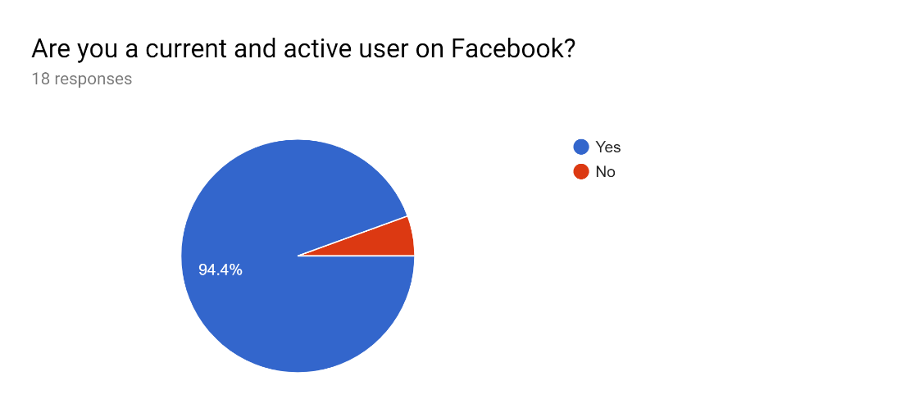Screener questions determined suitability of an applicant based on which platform the user accesses the Facebook application with, if the user selected a different platform compared to Android, they were to be redirected to submit the form with no further questions.

Figure 1

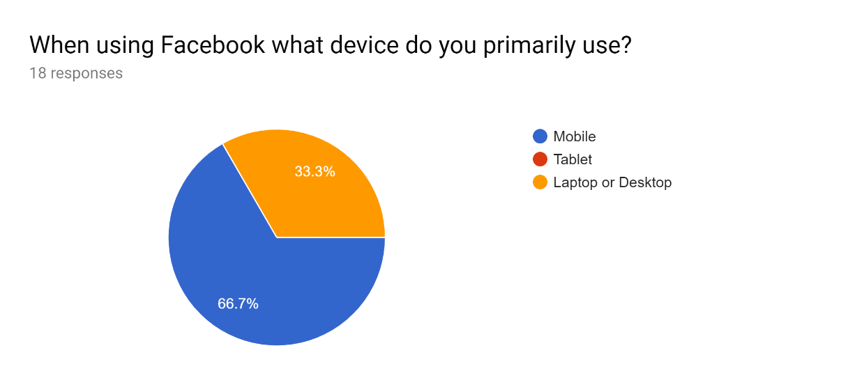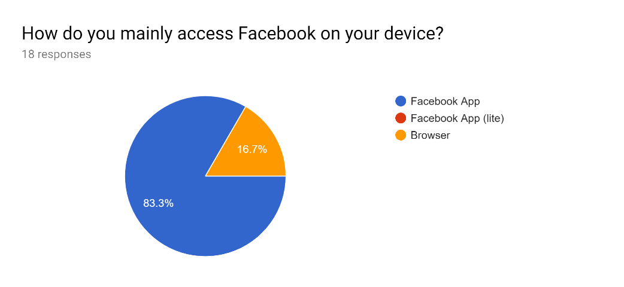

Figure 3

Figure 2

Based on the results of the screener questions above and the premise the scope is based upon, that user and technological trends show that access to Facebook is through mobile devices using the Facebook application. This validates the reasoning that to reach as many users of Facebook as possible was to select the scope on what platform the application was accessed from. However, the response count is only from a small portion of users and the evidence would be supported through further responses.

On the limited responses half of the respondants prefer to use an Android device, to which 83.3 percent of all 18 respondants prefer to use the Facebook application with only 16 percent using a browser. 17 survey participants as of the *3/01/20* are a current and active user which leads to suggest the 18th respondant has used facebook based on the other screening questions and survey section results but is not currently using the application.

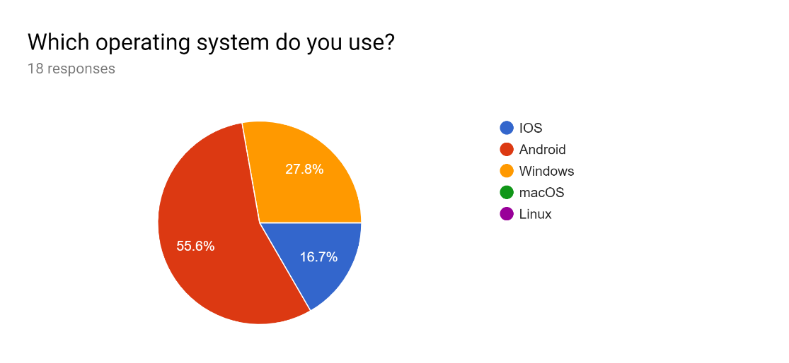This section focuses on all users of Facebook, as creators and collaborators must have a personal account to be able to interact with groups and business on Facebook itself. The questions cover a users experience with the application and how often they use it to complete tasks they set out, however the scope of the survey is on accessing their profile, customising it and posting content using their personal profile. There are a variety of closed and open ended questions including an overall opinion on the application as to any issues the user might have but is not necessarily in the scope but may have a correlation to the scope and to the heuristics.

Figure 4

Account access

These questions determines the users experiences with the application when performing tasks and leads to further questioning as to why the user selected Facebook on an Android device as their preferred platform. However, this has implications towards the other sections of questions as a users experience will affect their opinion of not only accessing a personal account but a group and business page to enable the user to interact with the ascociated pages.

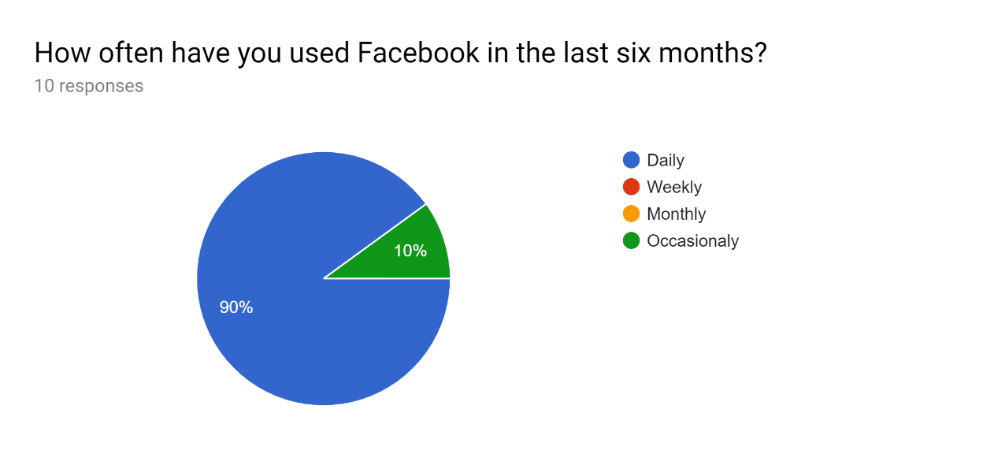

Asking if the user regularly accesses their accounts, indicates previous experience with the platform and being able to form an accurate opinion on the underlying issues.

# Personal account

“Why do you use this device over others when using Facebook?”

“*It’s easier and more convenient”*

This section leads to the reasoning why users access Facebook on an Android platform and supportive evidence to the screening questions and further lines of questioning. The survey results indicate why users utilise the platform and application as the question “Why do you choose to use the Facebook app?” produced the expected answers, concluding that the application on the users device is flexible, convenient, ubiquitous and easy to use.

As the previous questions highlighted that the Facebook application is flexible and easy to use even through mobile technology. When asked “When logging in are there any issues when using your preferred device and method?” participants stated that they didn’t. Even when Facebook updates as 70per cent percent of the participants would keep the application up to date, would have no issues. However, a user using an older device stated “Difficult, it's a pain in the butt on my phone at times. I have an older phone too.”, would suggest that users may have difficulties with older hardware. Similarly, some users would not update and have issues when choosing not to update the application.

When participants would reset their passwords “it’s easy to reset password”, is a common theme in the responses received. This concludes that users generally do not experience difficulties gaining access to a personal account through an Android device unless they use legacy hardware or fail to update the application.

# Group Page

The line of questioning establishes the ease of access to a group page using the same device as the participants use for the personal accounts. Regardless if the user is the administrator of the group page or a current user who regularly participates and signs up to group pages. For the majority 55.6per cent percent of the survey participants of the group page are administrators and participants with the rest as just participants. Therefore, it is not difficult for users to gain access to a group page, however based on the responses if the application assisted in finding a group or participating in one received mixed opinions. This leads to suggest the method in locating the groups or participating can be improved upon, but this would require further questioning into the process and more participants.

# Business Page

Similarly, with the group page participants the exact figure for business pages are identical as to the number of users are administrators. Users were asked, “When trying to access the business page, do you have any difficulties?” only one respondent indicated they do sometimes but provided no further clarification on the issue.

# Customisation

Customisation of a personal, group or business page refers to; uploading a profile or cover photo, changing basic information displayed publicly, changing security and privacy settings. The other task in changing settings is administration to do with a group page or a business page with which users have permissions to alter the pages. Customisation of a Facebook profile can be defined as any instance of a setting which can be altered by a user to personalise and modify the layout, appearance and functionality of a page.

This line of questioning analyses the ease of which users can customise a personal profile and are able to alter settings and personalise the profile. If the users are the administrator of the group or business page the same questions are posed but specific to the context of the page.

# Personal acount

The customisation of a personal profile is reliant on the user’s ability to login and access their account, including in the event of forgetting and resetting their password. It is also assumed that based on the previous answers that the user can be able to navigate through settings and menus. From the results of the survey 70 percent change the profile settings regularly and reported no issues when attempting to alter the settings of a personal profile.

# Group Page

Group Page customisation a third of the responses out of the 55 percent who are administrators of a page indicate there is an issue when trying to change a setting on a group page, however none could elaborate on the issue, “Can’t specify exactly as I didn't create any community”. Users capable of changing the setting should also have the experience to navigate through the layout with the appearance of the interface, but one user sometimes has trouble locating menu items.

# Business Page

On the business section, users had indicated no difficulties when trying to change the settings and customising the business page.

# Posting content

As the survey indicated, posting content is not an issue in the Facebook Android application as participants indicated they didn’t stating “it’s easy to make a post” and the participants that did, didn’t provide an explaination to their answer and have been diregarded. Regardless of the situation in which the user makes a post in a profile, group or business and all participants stated similary that there was “no issue”.

# General Feedback

There were a few questions with the application overall and any issues that may impact on the processes of completing tasks in the application. For instance, locating groups and businesses received mixed responses such as “Simpler searching for businesses” which suggest that this may hinder a user carrying out the tasks. “Sometimes when using the mobile app and trying view posts from groups it mixes up posts instead of showing the most recent”, the following also suggests for some improvements for the group page feeds. Other feedback has been positive which is supplemental to the results and supportive evidence of user statements.

Suggested improvements

* Improve on the functionality of searching for external pages from a personal account.
* Improve on the functionality of the feed for group pages.

# Conclusion

Overall the Facebook application on the Android application is successful in its functional interface and flexibility in a mobile context and delivering a user friendly application. Moreover, Facebook is consistent with it appearance, layouts including menus and its functionality enabling experienced users to operate the application with out many issues. However, this is a limited analysis and specific areas could be analysed more extensively with a survey corresponding with a greater number of participants for more supportive evidence.

References

Nielsen Norman Group. (2019). *10 Heuristics for User Interface Design: Article by Jakob Nielsen*. [online] Available at: https://www.nngroup.com/articles/ten-usability-heuristics/ [Accessed 27 Dec. 2019].

Kumar, V. (2020). *10 Really useful Facebook App Tips and Tricks for Android Mobile*. [online] Pro Hacker. Available at: https://www.prophethacker.com/2016/03/facebook-android-app-tricks-tips.html [Accessed 3 Jan. 2020].

Zephoria.com. (2020). [online] Available at: https://zephoria.com/top-15-valuable-facebook-statistics/ [Accessed 3 Jan. 2020].

Digital Marketing Agency Canberra. (2020). *Social Media Statistics - World + Australia - Digital Marketing Agency Canberra*. [online] Available at: https://www.exalteddigital.com/social-media-statistics-world-australia/ [Accessed 3 Jan. 2020].

Omnicoreagency.com. (2020). *• Facebook by the Numbers (2019): Stats, Demographics & Fun Facts*. [online] Available at: https://www.omnicoreagency.com/facebook-statistics/ [Accessed 3 Jan. 2020].

Facebook. (2020). *Facebook – log in or sign up*. [online] Available at: https://www.facebook.com/ [Accessed 3 Jan. 2020].